


Module Code & Module Title
CS5004NA Emerging Programming Platforms and Technologies

Assessment Weightage & Type
50% Group Coursework
Title (Where Required):
Year and Semester
2019-20 Autumn

Group Name:
SN | Student Name | College ID | University ID
1 | Aashish Shrestha | NP01CP4A180201 | 18030037
2 | Sagardip Poudel | NP01CP4A180196 | 18030027
3 | Amul Dhungel | NP01CP4A180197 | 18030029

I confirm that I understand my coursework needs to be submitted online via Google Classroom under the relevant module page before the deadline in order for my assignment to be accepted and marked. I am fully aware that late submissions will be treated as non-submission and a marks of zero will be awarded.

Table of Contents
1. Introduction 1
2. List of Data 2
3. List of Features 3
3. Tools Used 4
3.1. Java 4
3.2. NetBeans 4
4. Report 5
4.1 Binary Search Algorithm 5
5. Conclusion 8
6. References 9

Table of Figures
Figure 1: Binary Search (geeksforgeeks, 2020) 5
Figure 2: Login Page 6
Figure 3: Dashboard 7

1. Introduction
According to the given coursework, we have decided to develop a java swing-based application. We have chosen to make a Rocket Information System Application, where the administrator can add information on any rocket build by any space agency or a manufacturer. This application allows the user to add any necessary information on rockets easily as our main goal is to make this application look good, user-friendly, fun to use. The GUI builder will help us to make it look and feel great and the user to have best experience while using our application. This will help the user to understand about the capabilities of the rocket. This project cannot be accomplished by the effort of single man, thus our group members will have meetings, understand the proposal until our imagined application becomes a reality.

2. List of Data
The Rocket Information System will have a form to input the Rocket's data and add it to the System. The form will have following type of inputs:
- Rocket ID: Unique Id for each Rocket. (Integer)

- Rocket Name: The name of the rocket. (String)

- Rocket type: The types of module. (String)

- Manufacturer: The name of Manufacturer of the rocket. (Stored as a String)

- Payload: Radio Button to choose the varieties of payload capabilities. (Stored as an Integer)

- Price per Launch: Total cost to launch a rocket. This include fuel price, refurbishment etc.(Integer)

- Price to Build: The total price to build. (Integer)

- Total launches: The total no. of successful flight it has accomplished. (Integer)

3. List of Features
- This Simple Software will have the capability of adding information about rocket and space agency's specific data via the user’s input.

- The stored data will be shown in the Table and is refreshed every time the information about new rocket is added.

- Rocket's information can be searched according to the Price as well as see Manufacturer who built it.

- The Table is intended to be made with JTable from swing package.

- The space will be perfectly utilized simultaneously with the available screen and UI will be perfectly managed with creative User interface.

3. Tools Used

3.1. Java
Java is a programming language that produces software for multiple platforms. When a programmer writes a Java application, the compiled code (known as bytecode) runs on most operating systems (OS), including Windows, Linux and Mac OS. Java derives much of its syntax from the C and C++ programming languages. (Techopedia, 2019)

3.2. NetBeans
NetBeans is an integrated development environment (IDE) for Java. NetBeans allows applications to be developed from a set of modular software components called modules. It is great and easy to use as it provides drag and drop feature for the creation of GUI which will be perfect for this project. NetBeans also have the great features for the perfect design and minor combinations services.
The main reason for the use of NetBeans in creating this project are
- User settings
- Windows (placement, appearance, etc.)
- NetBeans Visual Library
- Storage
- Integrated development tools
- Framework wizard

4. Report

4.1 Binary Search Algorithm
Binary Search is an efficient algorithm to locate an object from a list of items that has been sorted. It works by repeatedly dividing in half i.e. By 2, the portion of the list that could contain the item, until you have narrowed down the possible locations to just one. The divide-by- two approach is the reason why the algorithm is known as the Binary search. (Khan Academy, 2020)
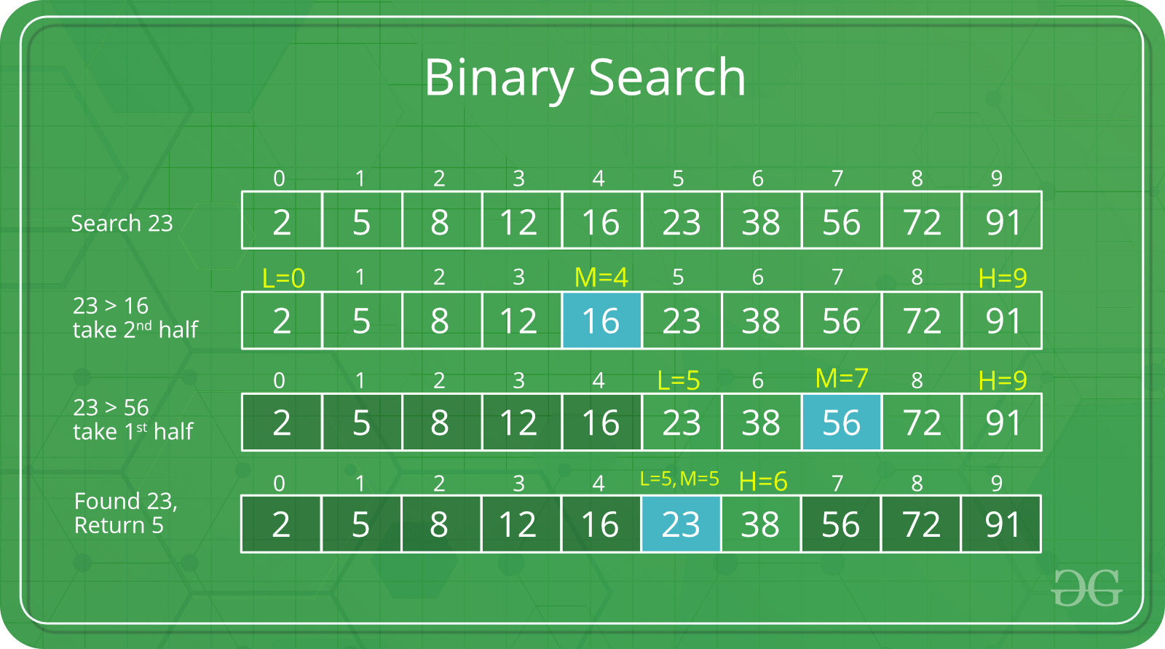
Figure 1: Binary Search (geeksforgeeks, 2020)
The above shows binary search algorithm perfectly. Here, user searches for number 23. At first, it compares the given number with the middle element. If the given number matches the middle element, it returns the middle index. However, if it does not matches and is greater than the middle element then 23 can only lie in the right half sub array. So it recurs for the right half ignoring the left half until it finds the exact number.
This same binary search algorithm concept is applied in our application of Rocket Information System.


Figure 2: Login Page
This is the Login page for our Rocket Information System Application. It asks the user for sign up if they are new to our application. If the user has already signed up to our system, they can directly login to our system.

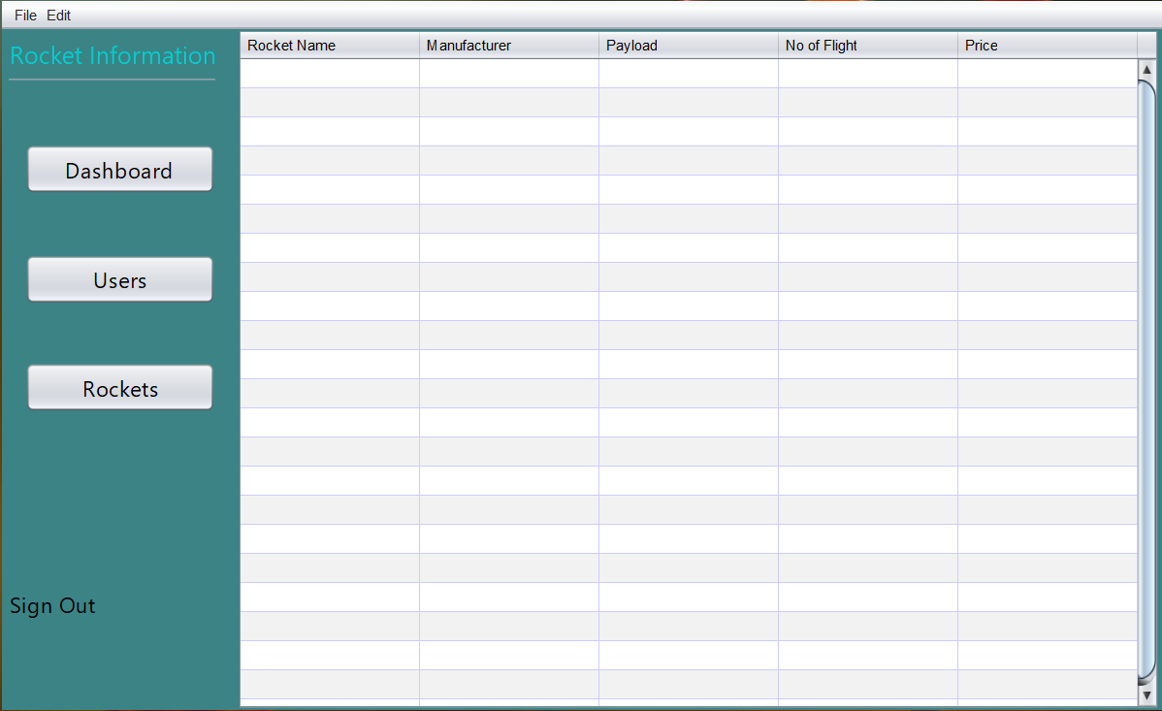
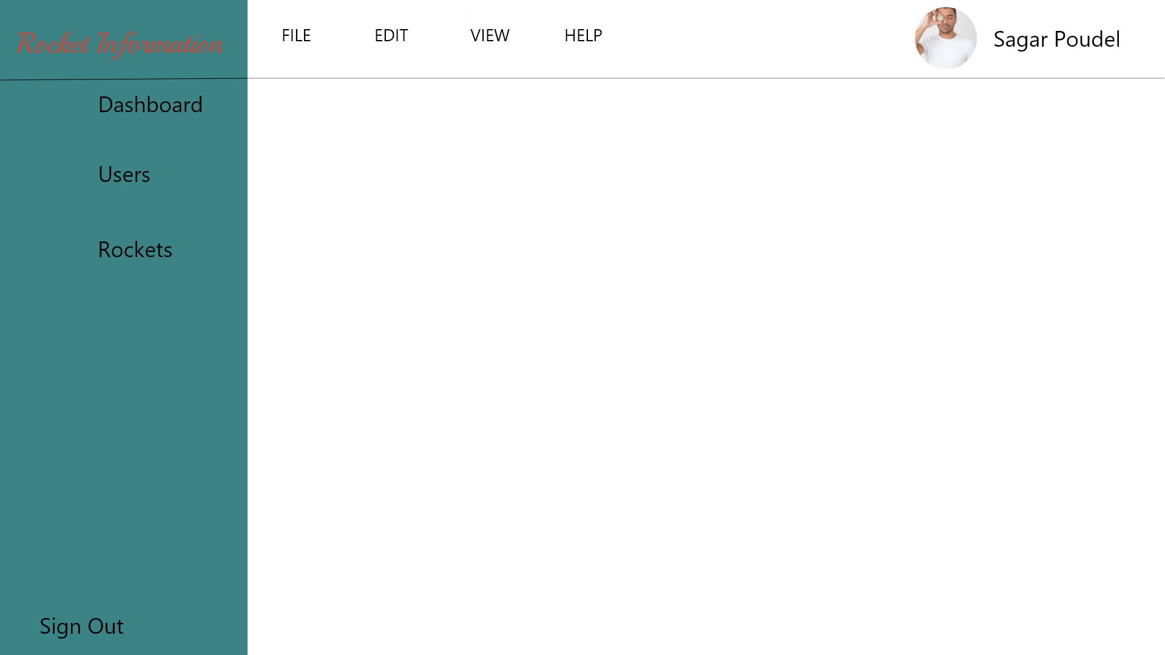
Figure 4: Dashboard (Java Swing)
Figure 3: Dashboad(Design Version)

This is the dashboard for our Rocket Information System Application where the user can view, edit etc. They can also take help from help menu bar if they have any confusion while using our system.

5. Conclusion
In this coursework, we at first decided to propose and develop an information system on Rocket. Then, we created the application according to the requirements with additional feature. Here, we have implemented binary search algorithm as our searching mechanism which we think is main component of this application.
Therefore, in conclusion we have learned to use Net Beans more fluently. Also, we know how to implement the binary search algorithm for the search function. This coursework was very helpful for us as it helped us improve our GUI designing, coding and documentation skills knowledge. Conceptually, binary search algorithm was easier for us to understand but implementing it in programming language was hard for us. However, lots of research and study was done to complete this group coursework on time. Completion of this coursework would not have been possible without the help from our teachers. All the knowledge and skills gained from this group work can utilised in future career as a programmer in every way possible.

6. References
geeksforgeeks. (2020, January 11). Binary Search - GeeksforGeeks. Retrieved from GeeksforGeeks: https://www.geeksforgeeks.org/binary-search/
Khan Academy. (2020, January 10). Binary search (article) | Algorithms | Khan Academy. Retrieved from Khan Academy: https://www.khanacademy.org/computing/computer-science/algorithms/binary-search/a/binary-search
Techopedia. (2019, 12 17). Retrieved from www.techopedia.com: https://www.techopedia.com/definition/3927/java

